Type | Analyst | Action | 202404 |  |  |  |  |  |  |  |  |  |  | Total
Type | Analyst | Action | Week 16
Type | Analyst | Action | 20240415 | 20240416 | 20240418 | 20240419
Incident | BALOYIK7 | Other Update | 0 | 2 | 0 | 0 | 2 | 2 | 2
Incident | BALOYIK7 | Resolved | 0 | 1 | 2 | 0 | 3 | 3 | 3
Incident | BALOYIK7 | Status Change | 1 | 2 | 1 | 0 | 4 | 4 | 4
Incident | BALOYIK7 | Transfer | 1 | 2 | 2 | 0 | 5 | 5 | 5
Request | BALOYIK7 | Resolved | 0 | 0 | 0 | 1 | 1 | 1 | 1
Request | BALOYIK7 | Status Change | 0 | 0 | 0 | 1 | 1 | 1 | 1
Total |  |  |  |  | 1 | 3 | 2 | 2 | 7 | 7 | 7

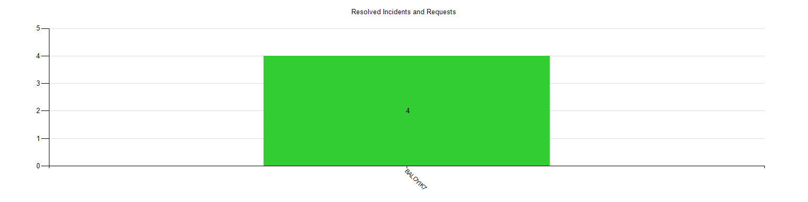
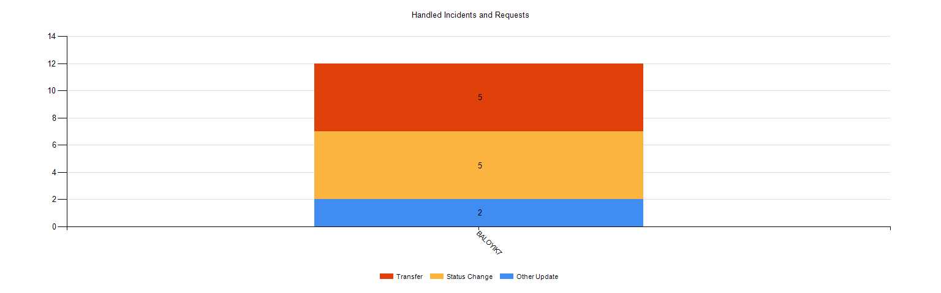

Time Stamp | Reference | Analyst | Action Description
2024-04-15 08:34:06 | 9059636 | BALOYIK7 | Status changed from 'Open' to 'Accepted'
2024-04-15 08:34:07 | 9059636 | BALOYIK7 | Transfer Assignee from '' to 'Baloyi, Kagiso K'
2024-04-16 09:32:10 | 9065322 | BALOYIK7 | Status changed from 'Open' to 'Accepted'
2024-04-16 09:32:10 | 9065322 | BALOYIK7 | Transfer Assignee from '' to 'Baloyi, Kagiso K'
2024-04-16 09:48:09 | 9065322 | BALOYIK7 | Status changed from 'Accepted' to 'Resolved'
2024-04-16 10:00:28 | 9064929 | BALOYIK7 | Status changed from 'Open' to 'Accepted'
2024-04-16 10:00:28 | 9064929 | BALOYIK7 | Transfer Assignee from '' to 'Baloyi, Kagiso K'
2024-04-16 10:21:34 | 9064929 | BALOYIK7 | FIELD='Type' OLD='Request' NEW='Incident'
2024-04-16 10:21:52 | 9059636 | BALOYIK7 | FIELD='Type' OLD='Request' NEW='Incident'
2024-04-16 10:26:18 | 9064929 | BALOYIK7 | FIELD='Parent' OLD='' NEW='9041123'
2024-04-16 13:12:31 | 9064929 | BALOYIK7 | FIELD='Parent' OLD='9041123' NEW='9043982'
2024-04-16 13:13:30 | 9059636 | BALOYIK7 | FIELD='Parent' OLD='' NEW='9043982'
2024-04-18 07:11:05 | 9068384 | BALOYIK7 | Transfer Assignee from '' to 'Baloyi, Kagiso K'
2024-04-18 07:12:34 | 9069889 | BALOYIK7 | Status changed from 'Open' to 'Accepted'
2024-04-18 07:12:34 | 9069889 | BALOYIK7 | Transfer Assignee from '' to 'Baloyi, Kagiso K'
2024-04-18 08:25:35 | 9069889 | BALOYIK7 | Status changed from 'Accepted' to 'Resolved'
2024-04-18 09:04:04 | 9068384 | BALOYIK7 | Status changed from 'Accepted' to 'Resolved'
2024-04-19 09:20:00 | 9072090 | BALOYIK7 | Status changed from 'Open' to 'Accepted'
2024-04-19 09:42:36 | 9068117 | BALOYIK7 | Status changed from 'Accepted' to 'Resolved'

